**PROJECT REPORT**

**DSD(Lab)**

**Project Name: “ obstacle avoider ”**

**Submitted By:**

**Group Members:**

1)Ateeq Ur Rehman

0976 994 1028

Section: B BB

**Submitted to:**

**Sir,SaleemUllah**

**Introduction:**

This project is about a controlled toy motor car,which can stop,moveforward,backward if detect an object.The complete description,each equipment work is given and explained below.

**Equipments Used:**

Two IR sensors,H-bridge,FPGA,Motorcar(toy)which can move forward and backward using DC motor

**Description:**

**IR Sensor :**IR Sensors work by using a specific light sensor to detect a select light wavelength in the Infra-Red (IR) spectrum. By using an LED which produces light at the same wavelength as what the sensor is looking for. When an object is close to thesensor, the light from the LED bounces off the object and into the light sensor.

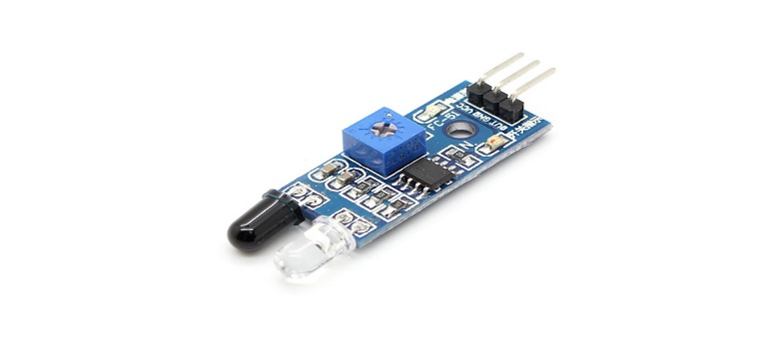

**H-Bridge:** is an electronic circuit that enables a voltage to be applied across a load in either direction. These circuits are often used in robotics and other applications to allow DC motors to run forwards and backwards.

**Diagrame:**

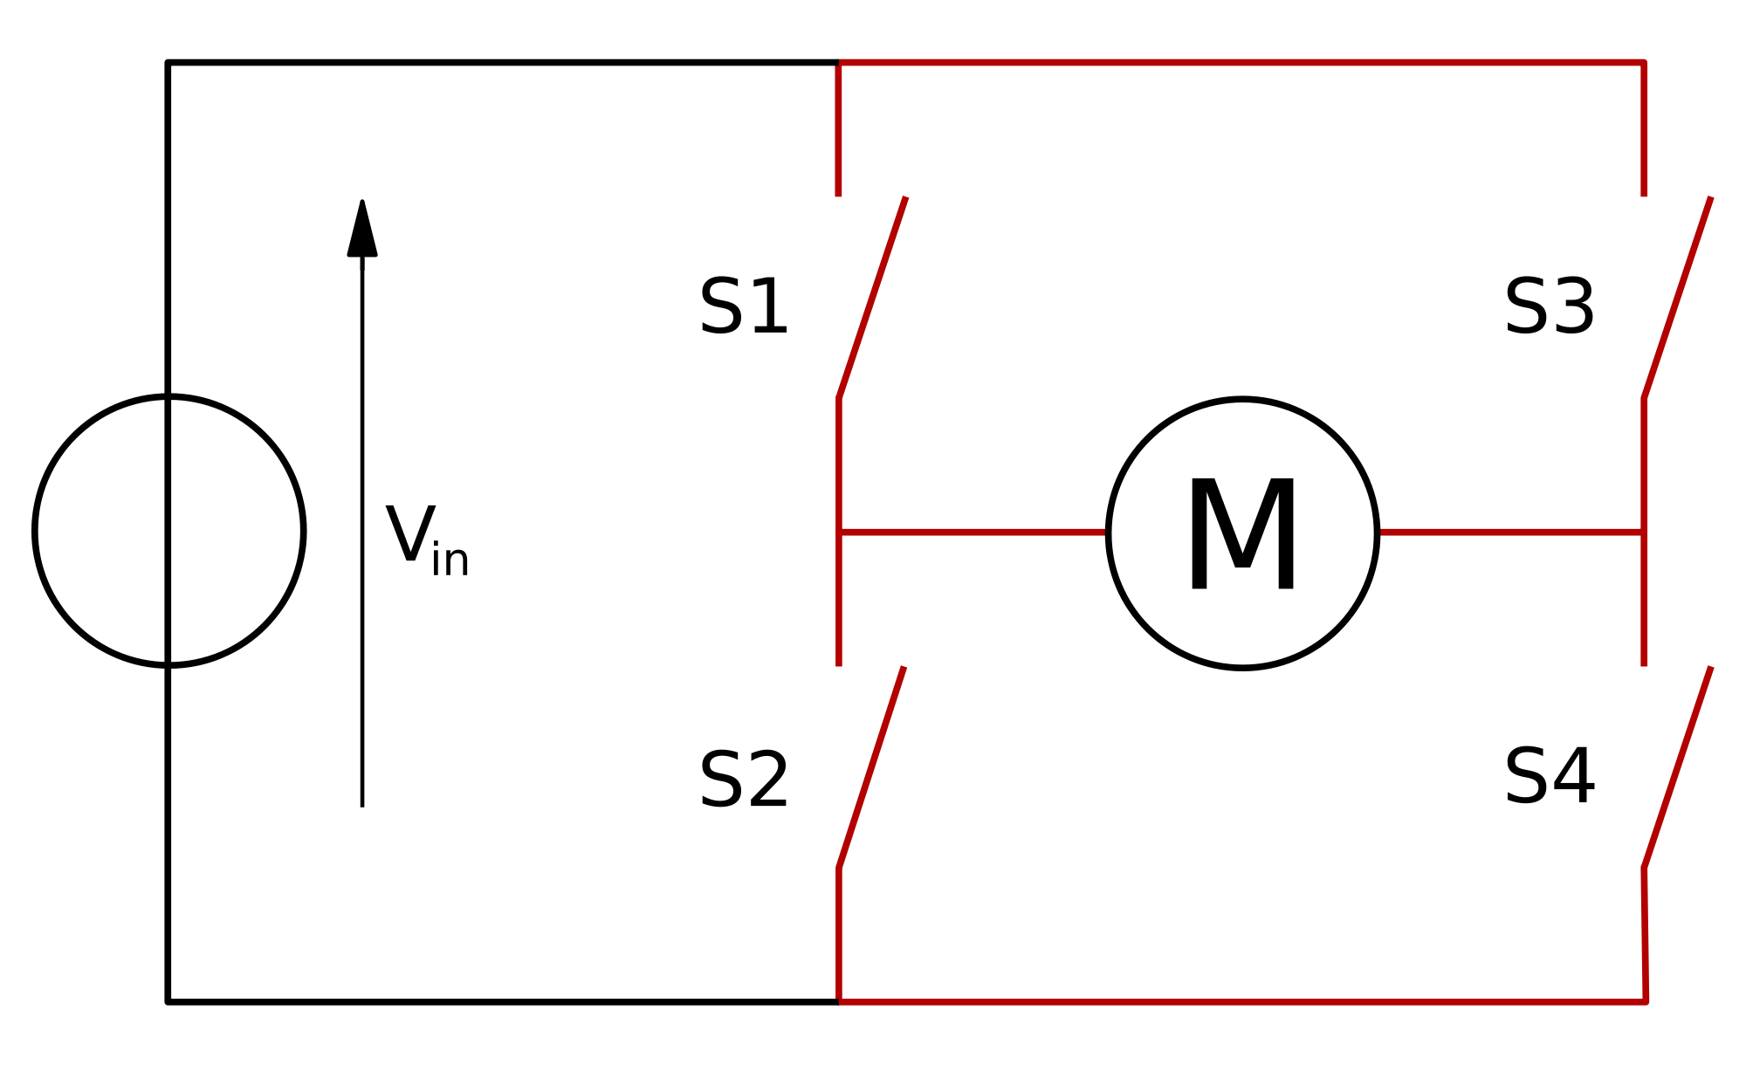

|  |  |  |  |  |
| --- | --- | --- | --- | --- |
| **S1** | **S2** | **S3** | **S4** | **Result** |
| 1 | 0 | 0 | 1 | Motor moves frward |
| 0 | 1 | 1 | 0 | Motor moves backward |
| 0 | 0 | 0 | 0 | Motor free runs |
| 0 | 1 | 0 | 1 | Motor brakes |
| 1 | 0 | 1 | 0 | Motor brakes |

**Code:**

**moduleob_avoider(sensor,out);**

**input [1:0] sensor;**

**output [1:0] out;**

**reg [1:0] out;**

**always @(sensor)**

**begin**

**case(sensor)**

**2'b00: out=2'b00;**

**2'b01: out=2'b01;**

**2'b10: out=2'b10;**

**2'b11: out=2'b01;**

**default: out=2'b00;**

**endcase**

**end**

**endmodule**

**Summary &**

**How this Project Work:**

The sensors detect object upon principles discussed above taken as input,by default motor runs free let farward if object detected back the motor run fraward and if object detected farward the motor reverse move back,ifbothe sensors detect the motor will be stopped.

This back and forward Motor running is work of bridge.

**Schematic Diagram:**

